# Current Advert Campaigns

## analysis

### WWF (forest fires):

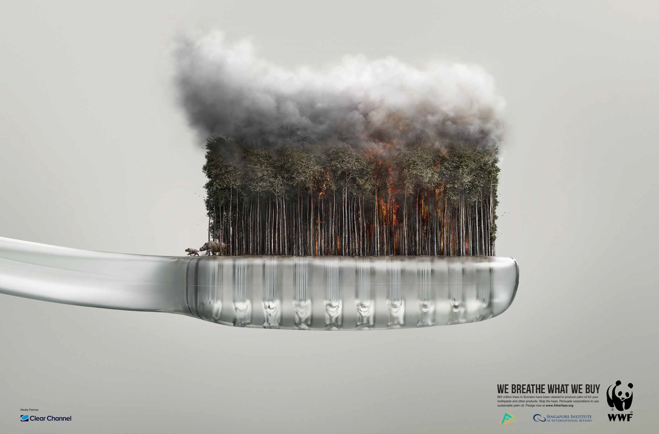

This successful poster uses techniques such as shock and an infeasible scene to draw the audience’s attention. The use of a familiar household object such as the disposable tooth brush helps make the poster relevant to people and make the audience feel more responsible for problem they are describing as generally people tend to separate themselves from the damage humans, generally, are causing. We hope to do this in our app by working out statistics based upon the user’s data which will display information such as how much ice they, personally, have melted this year or how many polar bears the have killed.

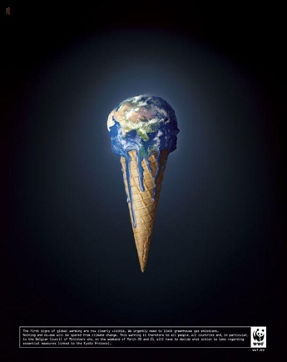**WWF (Global Warming):**

These posters show the world wasting away like a melting ice cream. This imagery gives the audience something to think about and relates to them through to the familiarity we have with an object like an ice cream cone and could make them feel more responsible for their actions. It should also hopefully make them think on how they can change their habits to make the economy/environment a better place.

### WWF (over/irresponsible fishing):

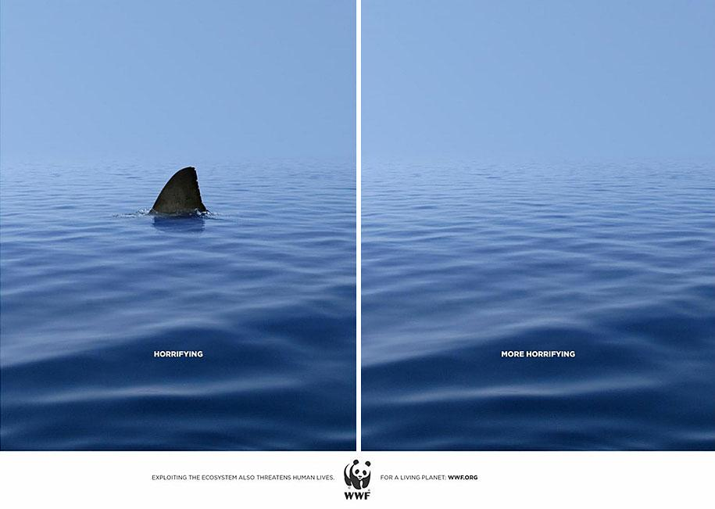The minimal approach depicted in this poster is aesthetically pleasing but also creates an eerie atmosphere, assisted by the seeming endlessness of the scene depicted. The poster is clever and use a common feeling of fear towards sharks to relate to the audience but also to help put into scale the gravity of animal extinction.

**Surfrider Foundation:**

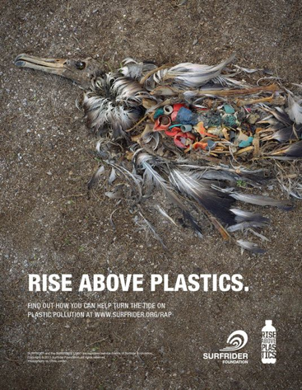The main attraction of this is portrayed through the use of a very graphic image of a dead bird. This poster has many aspects that I have found an interest in, such as the assertive nature of the image which effectively catches people's attention. I also like the minimal use of headings and colours, I think the use of a plain white, sans serif, bold header also displays the message assertively and clearly, the bleakness of the design reflects the subject matter.

Following this theme, the colour use in the rest of the image is also minimal, this ensures that the audience focuses on the main subject.

The decay of the bird is a graphic subject which could be upsetting for the audience. This poster touches the empathy of an audience that relates to this as they will probably want to start working on reducing the plastic output and being more careful of their littering usage. We can use this in our app firstly as we can use the data displayed for reference on statistical and data information and be able to use the name of the campaign ‘Surfrider foundation’ as reliable source. Hopefully we will also be able to incorporate some of the shock factor used here in our application to help motivate our users.